The Tableau HR Scorecard Measuring Success in Talent Management

Introduction

The Tableau HR Scorecard is a framework designed to measure and evaluate the success of talent management strategies within an organization. It provides a way for HR professionals and business leaders to track and analyze key performance indicators (KPIs) related to workforce planning, recruitment, retention, and development.

* 1. Over view

1. **Financial Perspective:** This perspective focuses on the financial impact of HR initiatives, such as the cost of recruitment, training and development, compensation and benefits, and turnover.
2. **Customer Perspective:** This perspective measures the satisfaction of internal and external customers of HR services, including employees, managers, and job candidates. It includes KPIs such as employee engagement, manager satisfaction with HR support, and candidate experience.
3. **Internal Process Perspective:** This perspective assesses the effectiveness and efficiency of HR processes, such as recruiting, onboarding, performance management, and employee development. It includes KPIs such as time to fill vacancies, time to productivity for new hires, and training hours per employee.

**2.** problem statement- Design thinking

* **Specify the business problem**
* **Business requirements**
* **Literature Survey**
* **Social or Business impact**

**2.1 Empathy Map**

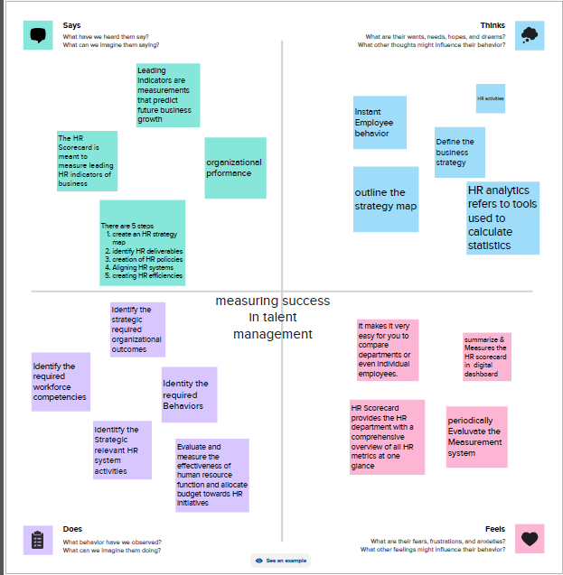

* 1. **Ideation and Brainstorming Map**

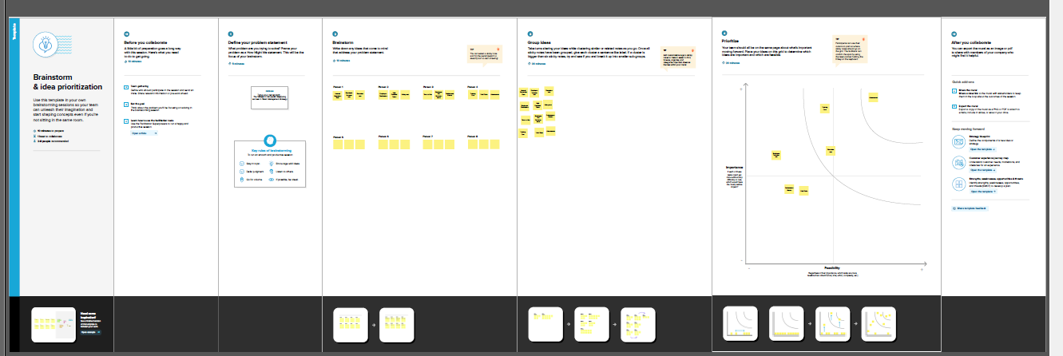

**3.Result**

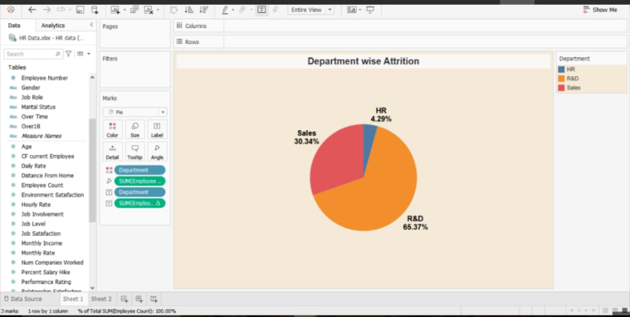

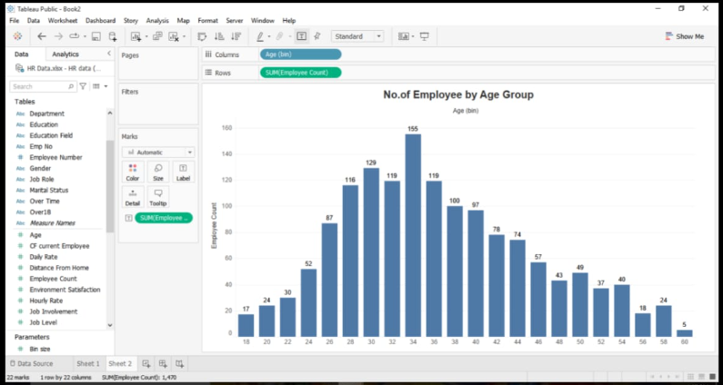

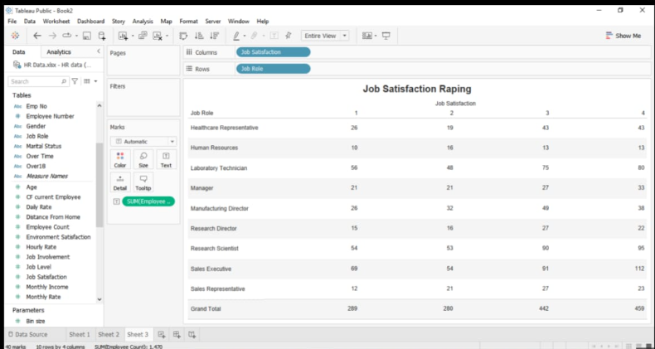

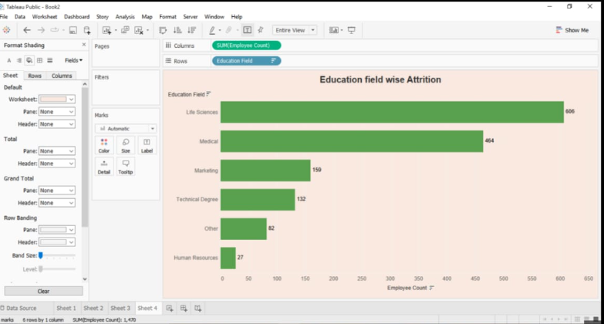

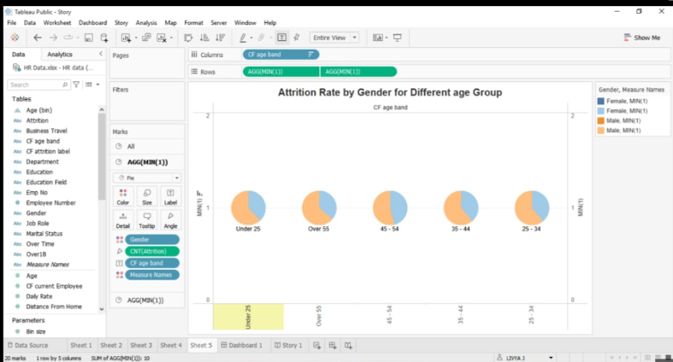

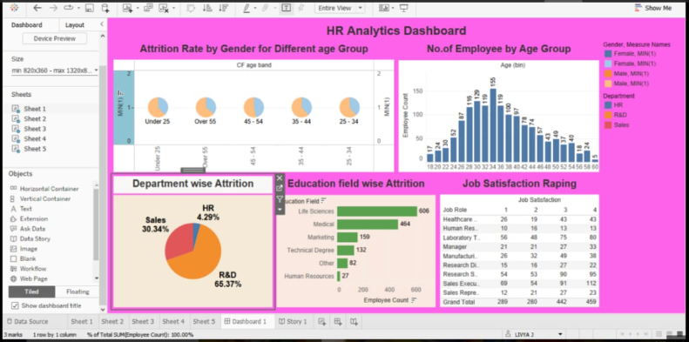

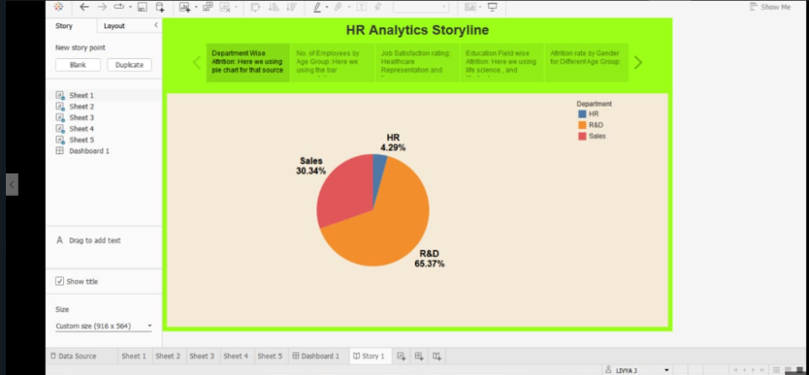

**4. Advantage and Disadvantage**

**Advantage**

**1. Gives structure to the strategy**

**A scorecard helps keep the goals at the center, uses specific parameters to track progress, and follows initiatives for monitoring actions.**

**2. Improves performance reporting**

**The HR scorecard can come in handy for designing performance reports and dashboards, ensuring the focus remains on critical strategic issues and helping the HR department monitor the execution of its plan.**

**3. Makes it easier to communicate the strategy**

**Having a scorecard takes the guesswork out of trying to understand everyone's responsibilities in the team and gets the entire department synced up under one structure. This also gives a much clearer picture of HR projects and initiatives."**

**Disadvantage**

**An HR scorecard visually represents the critical measures of the HR department's achievements, productivity levels, and other parameters - such as hiring costs, retention rate, time to fill, quality of hire, and so on - critical to the company's growth.**

**Most HR scorecards are tied to strategic plans and are designed to track and measure the efficacy of HR activities, enabling the leadership to make targeted investments in HR. Scorecards include current data and comparisons with previous periods.**

**A walk back in time: History of HR and scorecards**

**It is true when HR consultant and I/O psychologist Rob Silzer said, "Financial resources may be the lifeblood of a company, but human resources are the brains."**

**Traditionally HR was viewed as a support function that undertook basic tasks such as payroll, time tracking, and disputes between the organizations and unions. The role of the erstwhile personnel manager evolved into the HR we know today with the advent of the services sector.**

**5.Application**

**The HR Scorecard is meant to measure leading HR indicators of business performance. Leading indicators are measurements that predict future business growth. These are called HR deliverables. They are also known as HR metrics, and more specifically HR kas as they are metrics that are linked to the business strategy.**

**6. Conclusion**

**Apart from this, the fact that contemporary organizations, especially in the Services Sector, count their employees as the main asset means that they need to get the best out of their employees as well as understand how well such employees are contributing to the organization. The HR Scorecard is especially useful in such imperatives whereas Analytics is useful in measuring such indicators.**

**Thus, while the HR Scorecard is a reporting tool, the Analytics tool is a data gathering and analysis tool that can be used to discern trends and the Big Picture. This means that when used in conjunction, the HR Scorecard and the Data and Business Analytics tools can be used to both report and forecast measures of employee performance and broader organizational performance.**

**Indeed, the fact that the former reports measures and the latter finds patterns in such reports means that taken together, they represent a powerful combination.**

**7. Future scope**

**Lastly, when used together, the HR Scorecard and the Analytics tools can be used to actualize synergies and actualize efficiencies from the economies of scale.**

**Indeed, the fact that synergies accrue from the combination of reporting and analysis and which can drive efficiencies from scale since all employees can be covered means that Next Generation reporting and forecasting capabilities are within reach of organizations that use these tools.**

**In times when forecasts often fail the moment they are released, the power to measure and report with speed and accuracy is indeed an asset for organizations that seek to optimize their returns from their employees.**

**To conclude, using the HR Scorecard with Analytics represents a truly game-changing approach to business.**